PF102 Final Project: Inventory Management System for CiTech Computer Parts Shop

IT4A Group Members:

Mitra, Charles Brian C.

Quinto, Gianne Francis P.

Rosales, Anthony Christian A.

Torres, Juan Miguel C.

System Description/Purpose:

An inventory system that offers accurate computer parts inventory tracking and process. This system allows users to effectively monitor and update inventory records that ensures accurate stock levels, efficient order management, and optimal resource utilization as well as view the sales of the products. The system uses MySQL database.

System Features:

1. 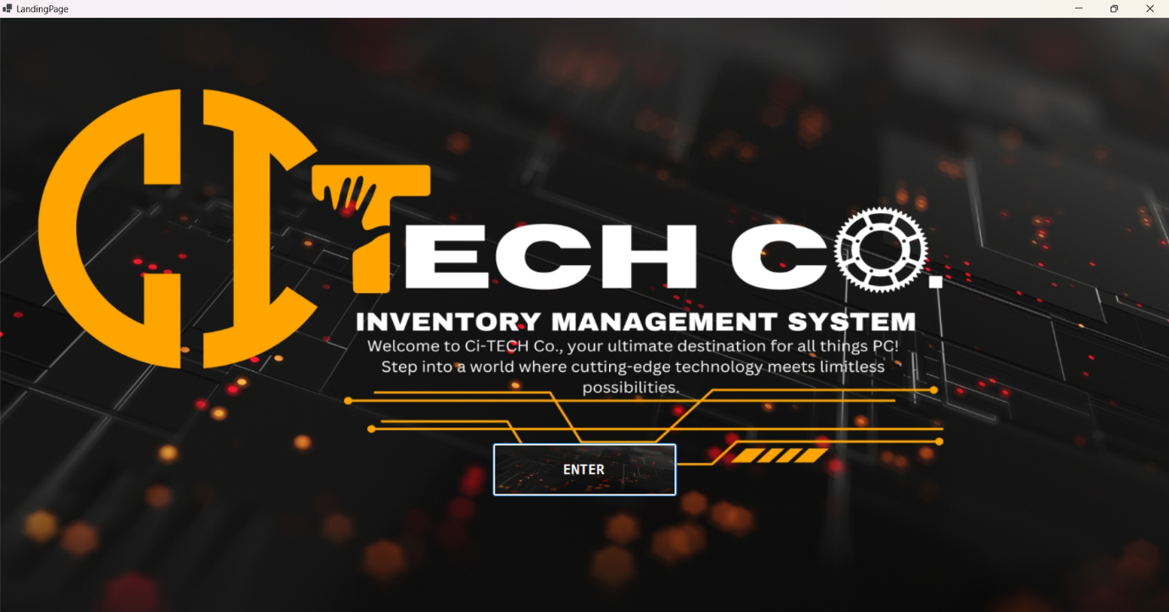Landing Page – This is the first page that the users will see when first opening the system.

2. Login Page – The login page lets the user login to the system. The inventory system has two types of users: the admin and the staff. If the user logs in using an admin account, it will lead to the admin dashboard. If the user logs in with a staff account, it will lead to the staff dashboard. It also has login validation in case there is an error in the login credentials or connection the database.

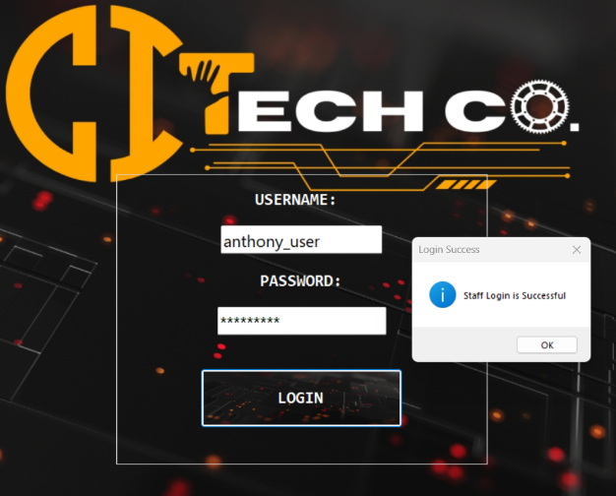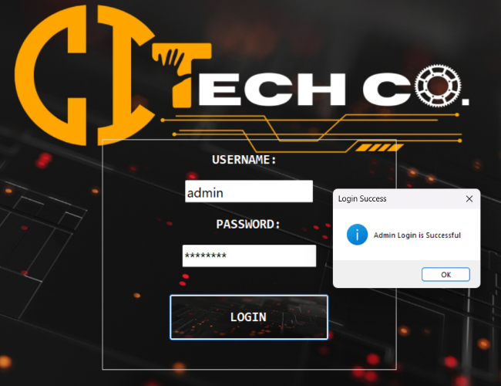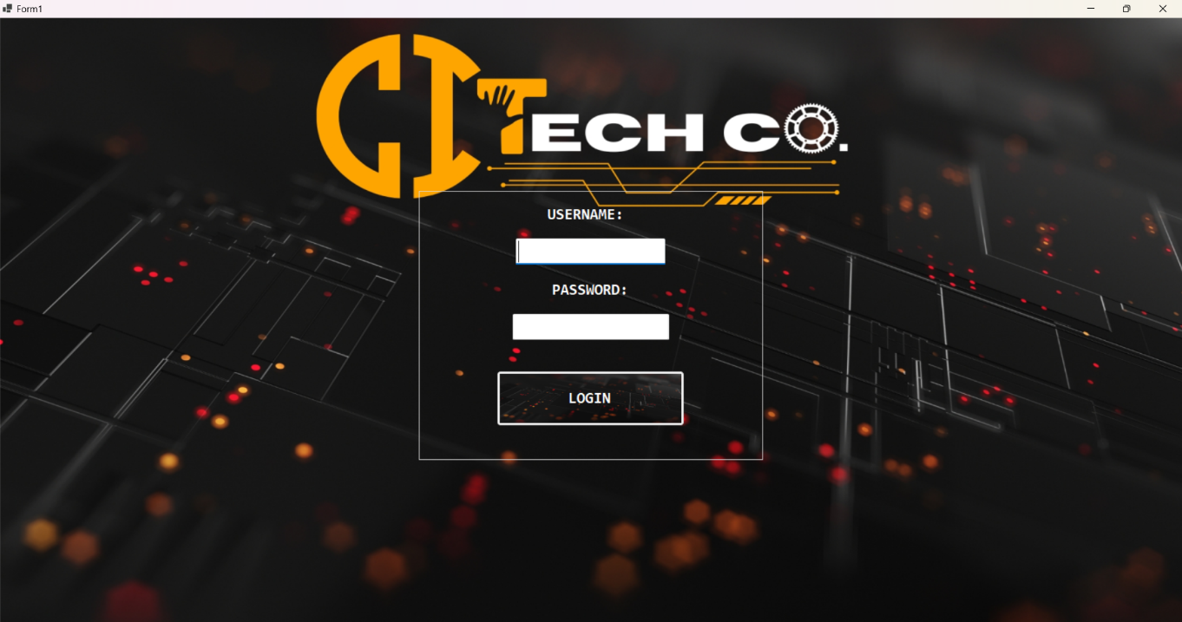

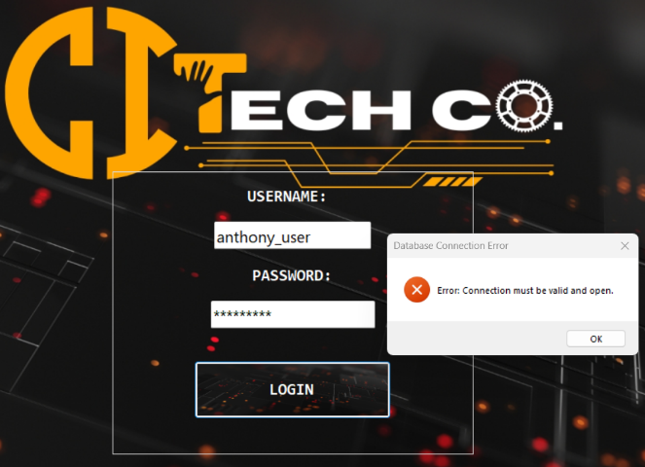

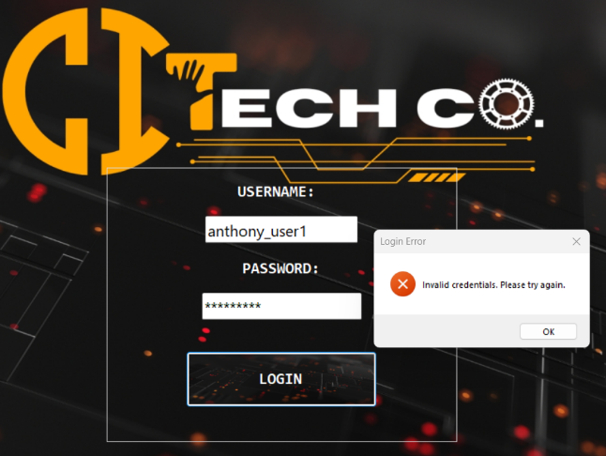

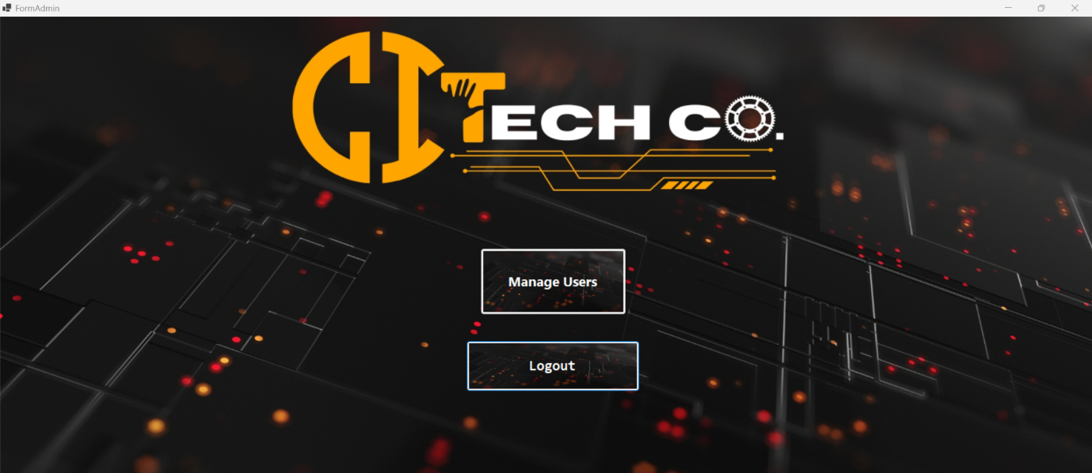3. Admin Dashboard – The admin account lets the user access the admin dashboard. The admin can manage the accounts created in the system.

4. Manage Users – This feature allows the admin to manage accounts in the system. It can let the admin update existing accounts, add new accounts, and delete accounts. When adding new account, the admin must choose whether it is a staff account or an admin account.

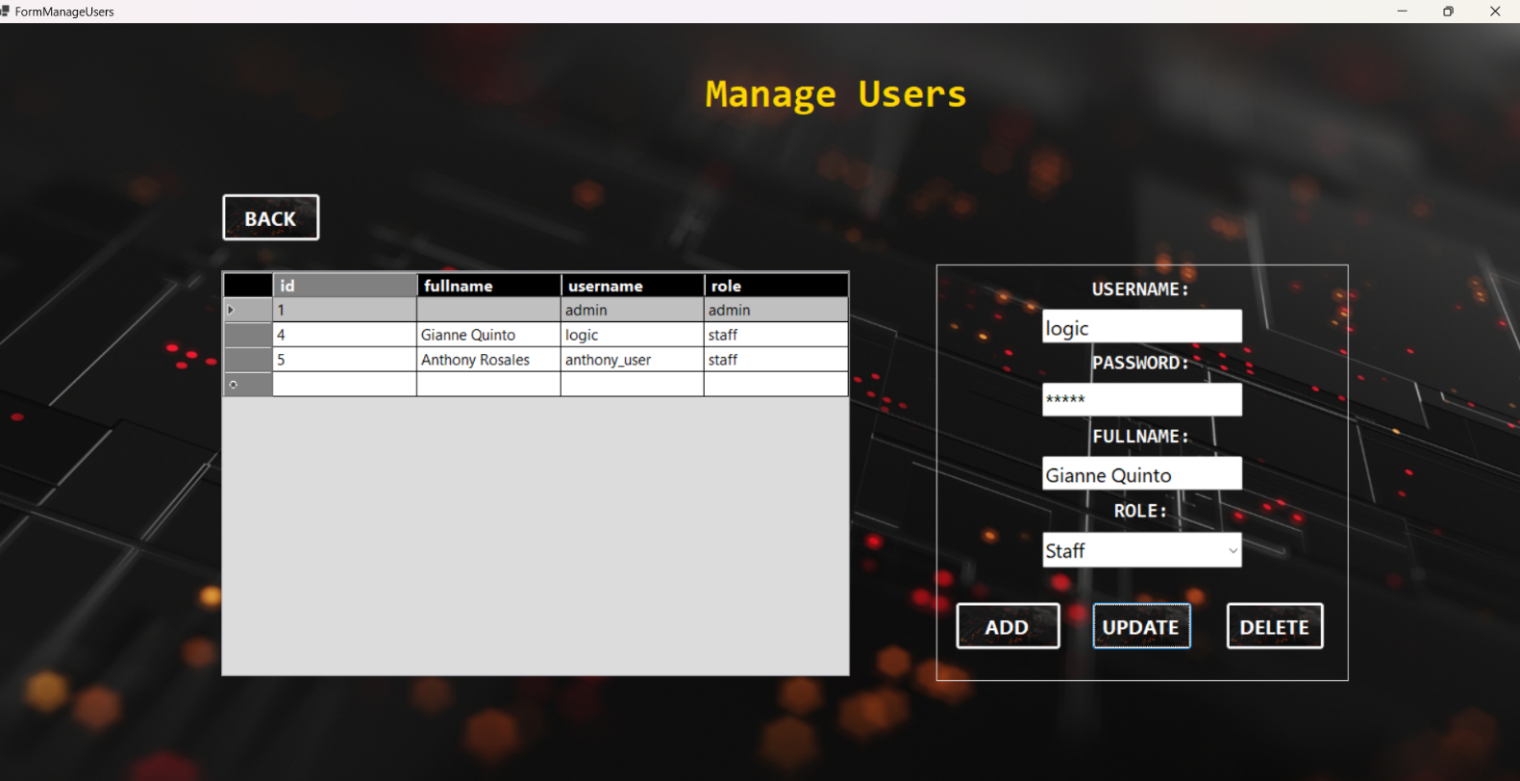

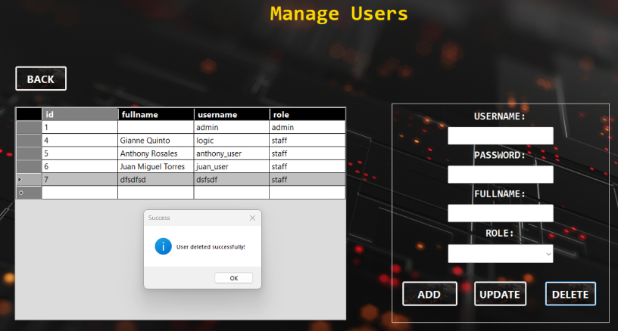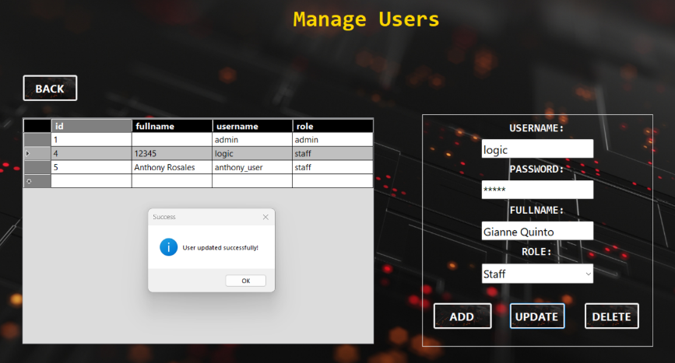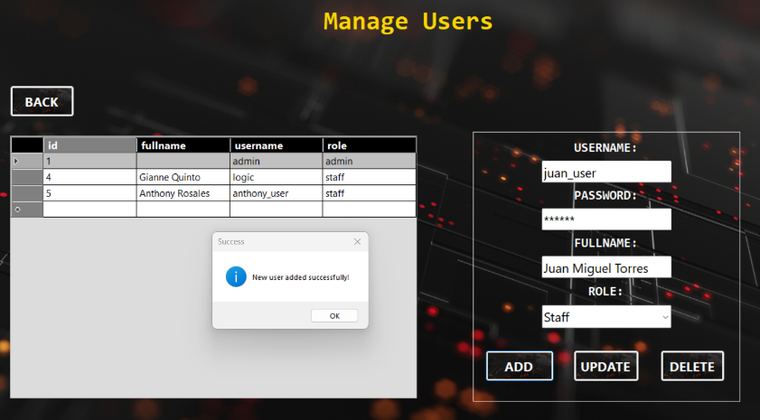

5. Staff Dashboard – The staff account lets the user access the staff dashboard. The staff account lets the user access the manage products and view sales features.

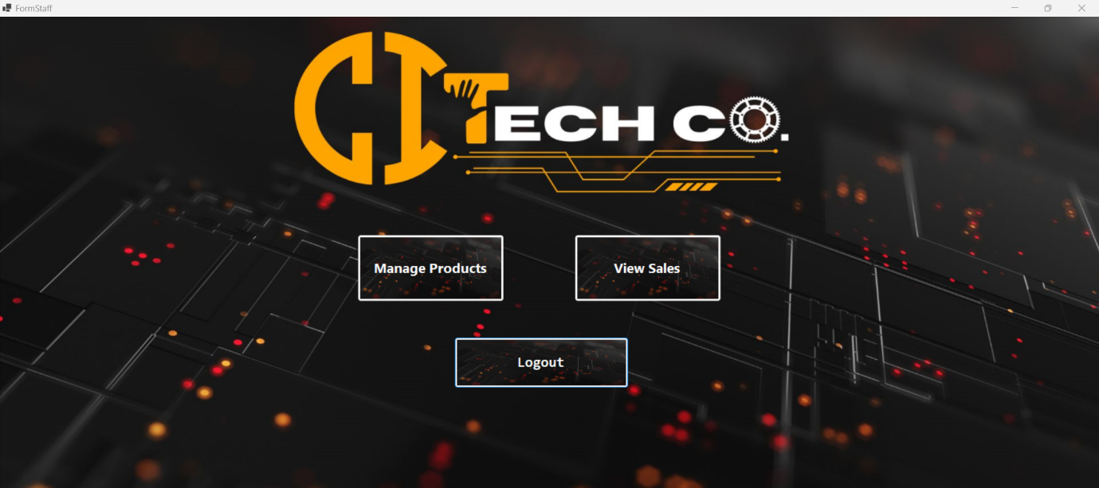

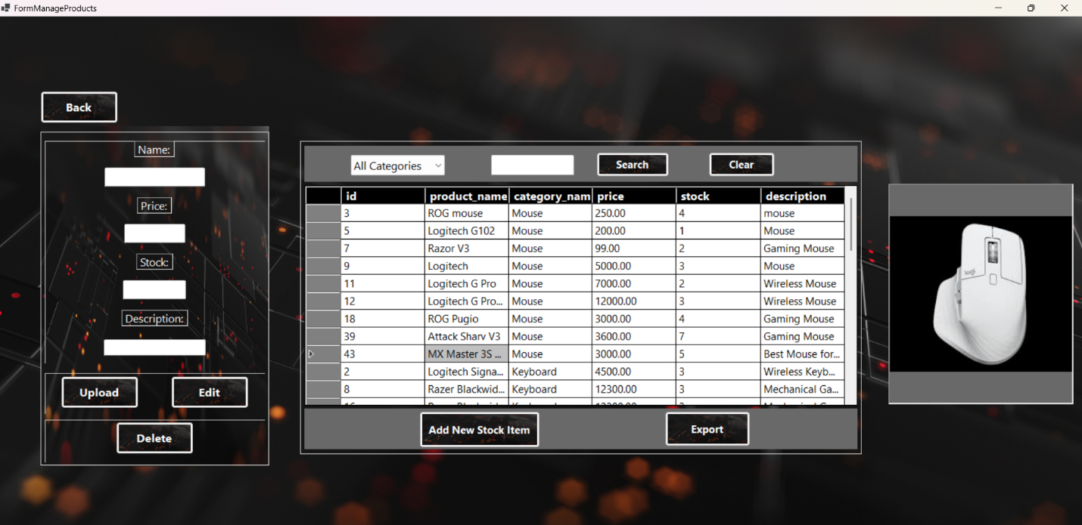6. Manage Products - This feature allows the staff to manage the inventory of computer parts in the system. It can let the users update existing products, add new products, delete products and upload the image of the product. When adding a new product, the staff must choose first what category of the product before entering the details of the product. When updating the product, the staff must click the entire row of the product in order to select and update it. The manage products also has a search function in which the staff can search for the name of product for easier find. The product can be filtered by category by choosing the category in the dropdown menu. It also has an export button in which it exports the inventory data to an Excel file.

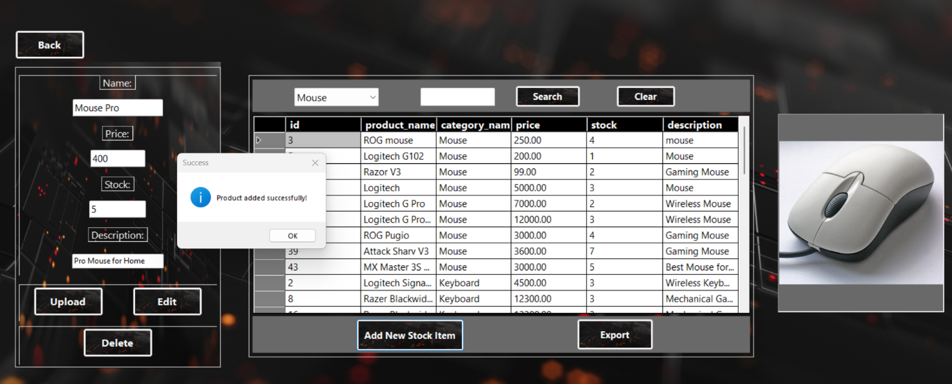Adding a new product:

Updating a product:

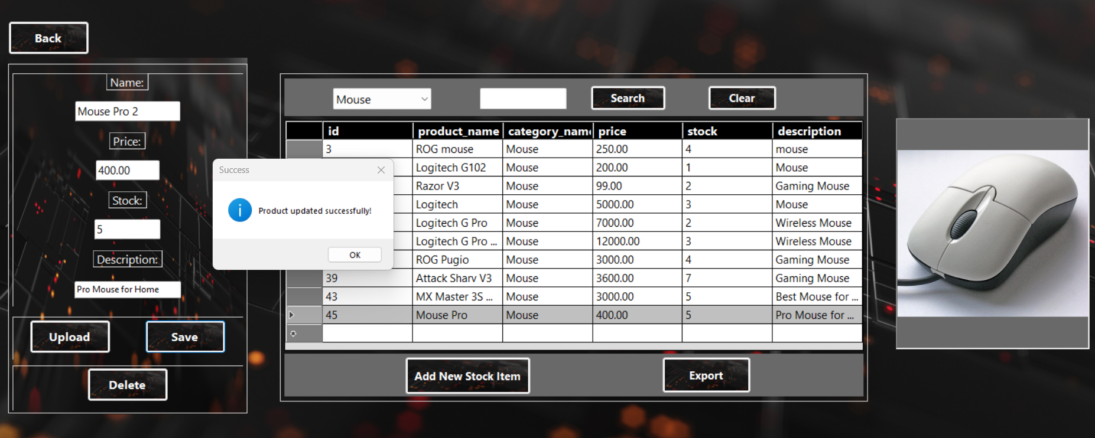

Deleting a product:

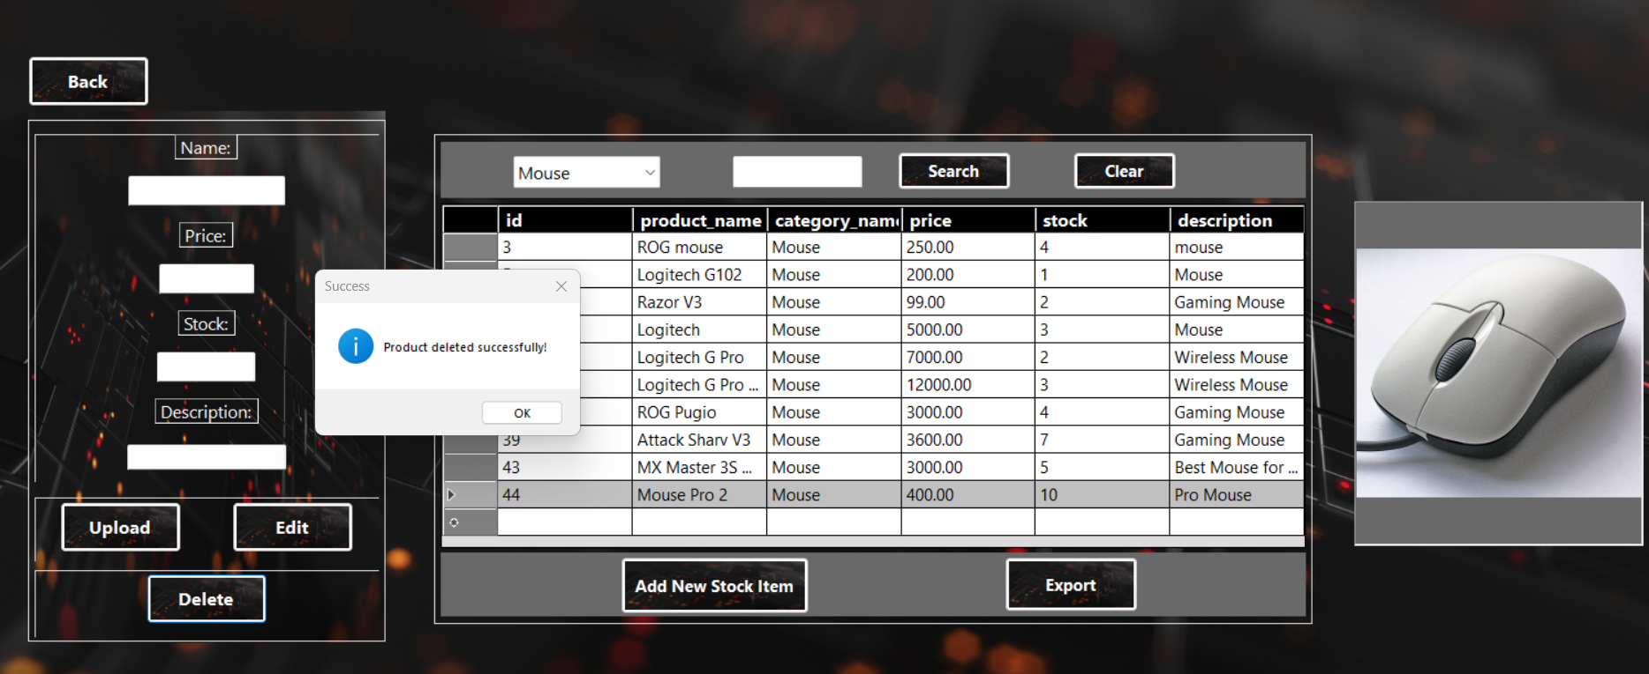

Using Search:

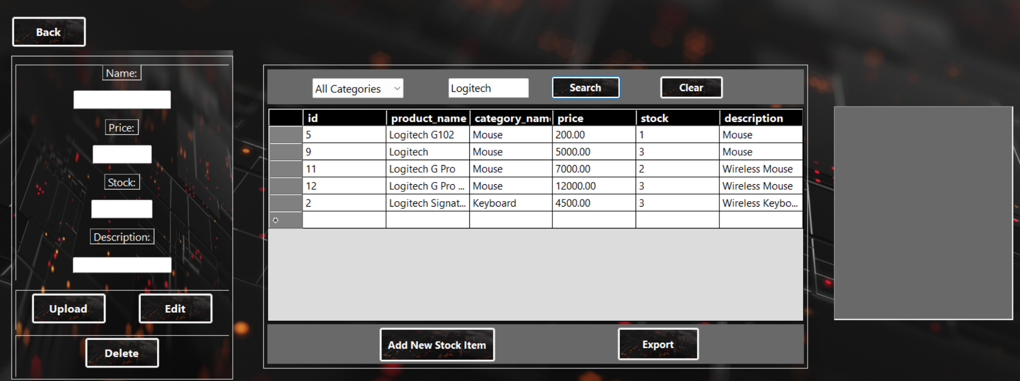

Filtered by categories:

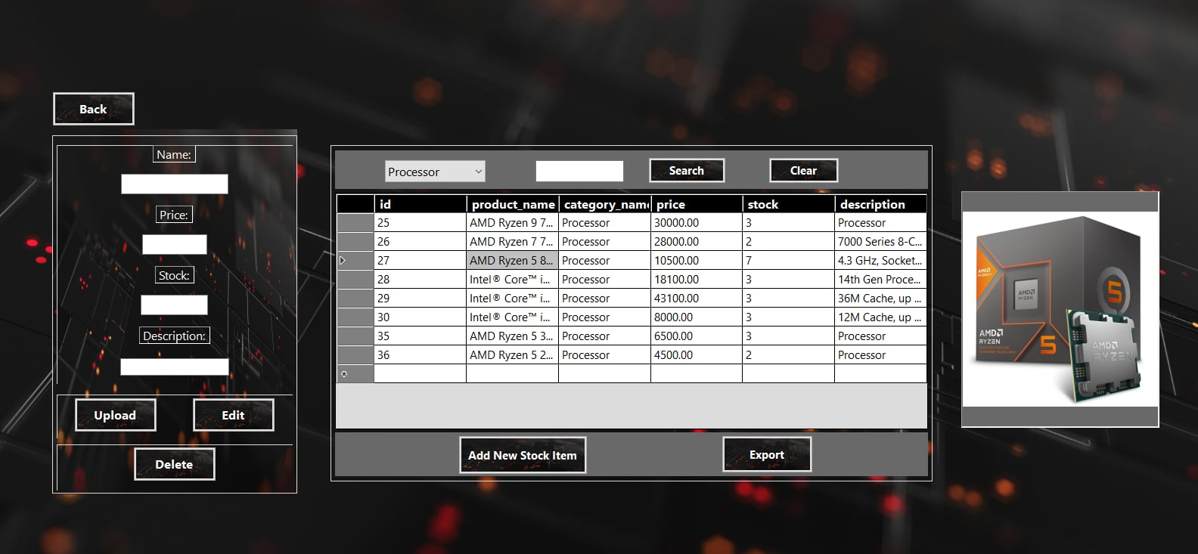

Exported inventory table in MS Excel when using the export feature:

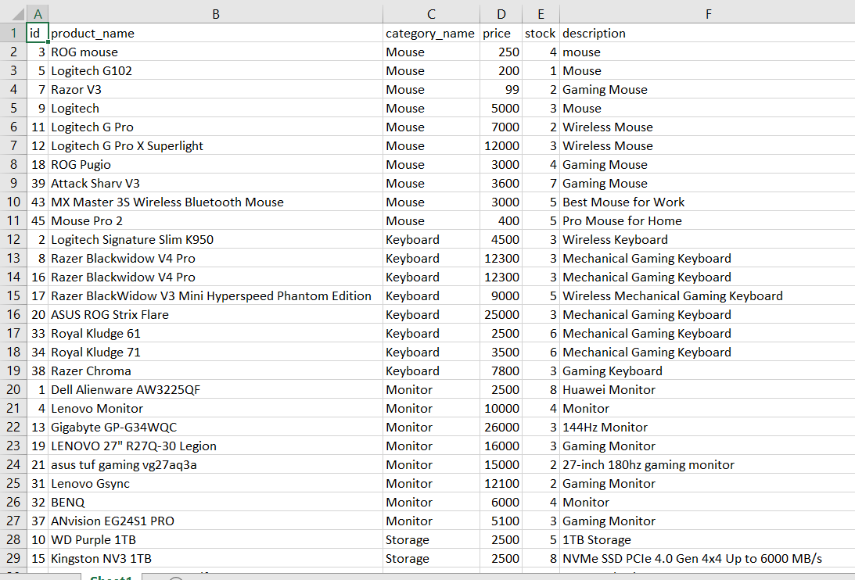

7. View Sales - This lets the staff see the current sales of the products. It can be filtered by date. It also has an export feature to export the sales data to an Excel file.

